Class Time:
Names:

Continuous Random Variables: Continuous Distribution Lab

Student Learning Outcome
- The student will compare and contrast empirical data from a random number generator with the Uniform Distribution.

Collect the Data
Use a random number generator to generate 50 values between 0 and 1 (inclusive). List them below. Round the numbers to 4 decimal places or set the calculator MODE to 4 places.
  - Complete the table

2. Calculate the following:
= __________
s = __________
1st quartile = __________
3rd quartile = __________
median = __________
Organize the Data
  - Construct a histogram of the empirical data. Make 8 bars.
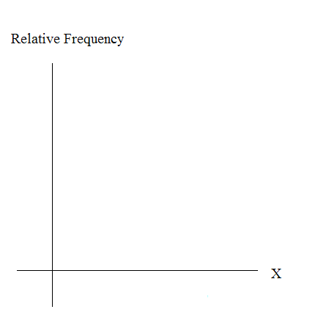

2. Construct a histogram of the empirical data. Make 5 bars.

Describe the Data

1. Describe the shape of each graph. Use 2 – 3 complete sentences. (Keep it simple. Does the graph go straight across, does it have a V shape, does it have a hump in the middle or at either end, etc.? One way to help you determine a shape, is to roughly draw a smooth curve through the top of the bars.)

2. Describe how changing the number of bars might change the shape.

Theoretical Distribution

1. In words, X =
2. The theoretical distribution of X is X ~ U(0, 1). Use it for this part.
3. In theory, based upon the distribution X ~ U(0, 1),
  - μ = __________
  - σ = __________
  - 1st quartile = __________
  - 3rd quartile = __________
  - median = __________
4. Are the empirical values (from “Collect the Data” (2)) close to the corresponding theoretical values in “Theoretical Distribution” (3) above? Why or why not?

Plot the Data

1. Construct a box plot of the data. Be sure to use a ruler to scale accurately and draw straight edges.

2. Do you notice any potential outliers? If so, which values are they? Either way, numerically justify your answer. (Recall that any DATA are less than Q1 – 1.5*IQR or more than Q3 + 1.5*IQR are potential outliers. IQR means interquartile range.)

Compare the Data

1. For each part below, use a complete sentence to comment on how the value obtained from the data compares to the theoretical value you expected from the distribution X ~ U(0, 1).
        - minimum value:

        - 1st quartile:

        - median:

        - third quartile:

        - maximum value:

        - width of IQR:

        - overall shape:

- Based on your above comments, how does the box plot fit or not fit what you would expect of the distribution X ~ U(0, 1)?

Discussion Question
- Suppose that the number of values generated was 500, not 50. How would that affect what you would expect the empirical data to be and the shape of its graph to look like?

